EVEN AND ODD
KS1 – 2002 Paper
1.
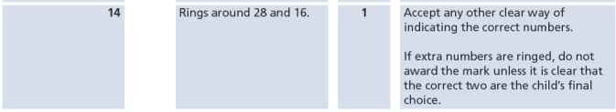
KS1 – 2004 Paper 1
2.
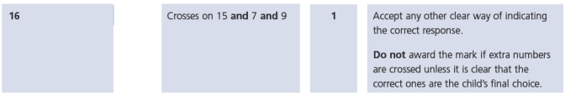
KS1 – 2009 Paper 1
3.
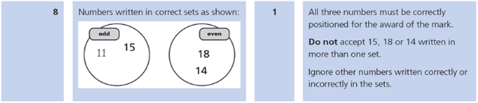
KS1 – 2016 Paper - Reasoning
4.
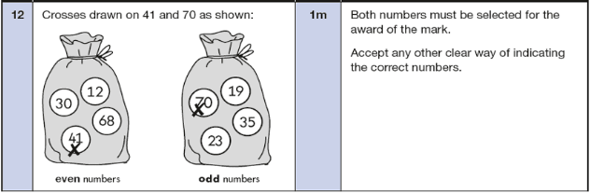
KS1 – 2017 Paper – Reasoning
5.
